Dashboard

A dashboard is like a control panel on a car—it’s a single place where you can see all the important information at a glance. In simple terms, it’s a visual tool that displays key data, metrics, or performance indicators in an easy-to-understand way, often using charts, graphs, or numbers.
For example, imagine you run a small shop. A dashboard could show:
- How much money you made today (sales).
- How many customers visited.
- Which products are selling the most.
- If you’re running low on stock.

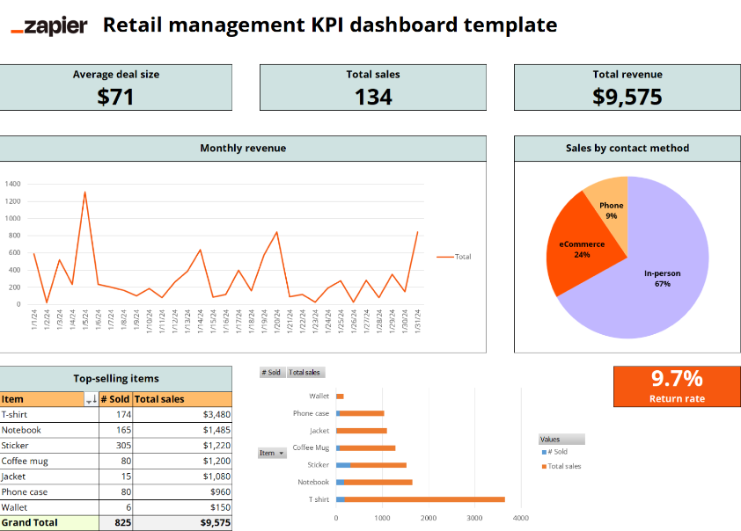

Charts

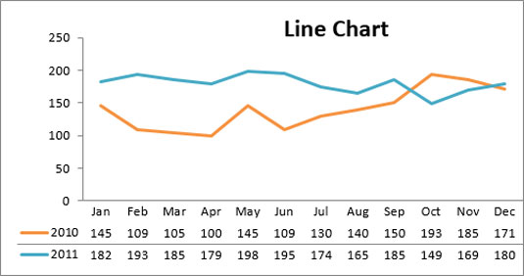
The line chart is one of the most frequently used chart types, typically used to show trends over a period of time. If you need to chart trends or changes over time, consider using a line chart

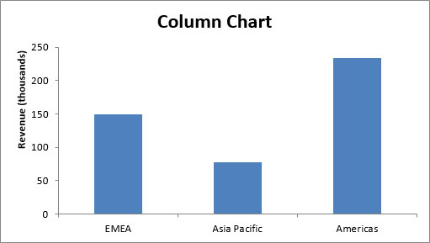
A column chart is typically used to compare several items in a specific range of values. A column chart is ideal if you need to compare a single category of data between individual subitems. For example, you may want to compare revenue between regions.

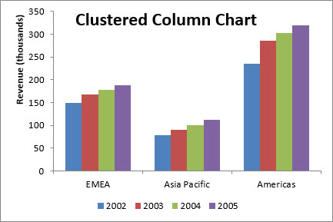
A clustered column chart can be used if you need to compare multiple categories of data within individual subitems as well as between subitems. For instance, you can use a clustered column chart to compare revenue for each year within each region and between regions.

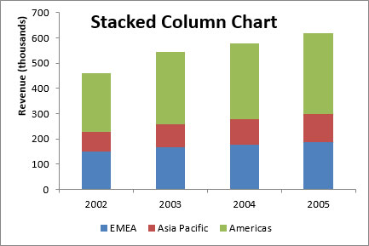
A stacked column chart allows you to compare items in a specific range of values and to show the relationship of the individual subitems with the whole. For instance, a stacked column chart can show not only the overall revenue for each year, but also the proportion of the total revenue made up by each region.

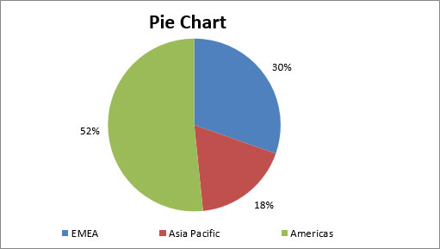
Another frequently used chart is the standard pie chart. A pie chart represents the distribution or proportion of each data item over a total value (represented by the overall pie). A pie chart is most effective when plotting no more than three categories of data.

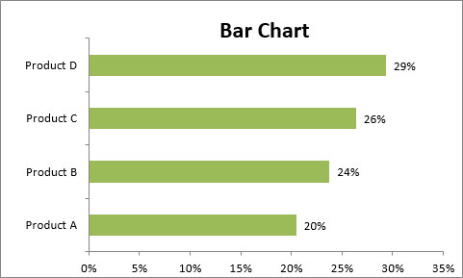
Bar charts are typically used to compare several categories of data. Bar charts are ideal for visualizing the distribution or proportion of data items for more than three categories. For instance, a bar chart can be used to compare the overall revenue distribution for a given set of products.

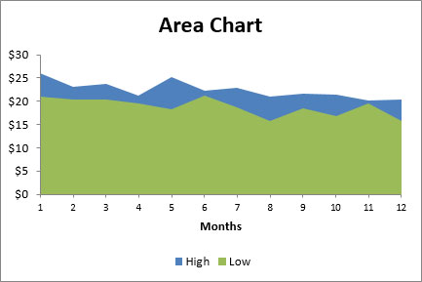
An area chart is ideal for clearly illustrating the magnitude of change between two or more data points. For example, you can give your audience a visual feel for the degree of variance between the high and low price for each month.

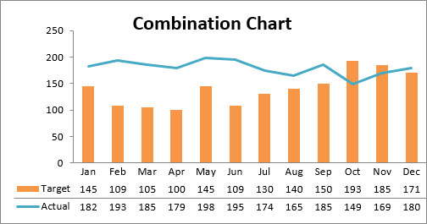
A combination chart is a visualization that combines two or more chart types into a single chart; this type is the ideal choice when you want to compare two categories of data for each individual subitem. A combination chart is commonly used to create visualizations that show the difference between targets versus actual results.

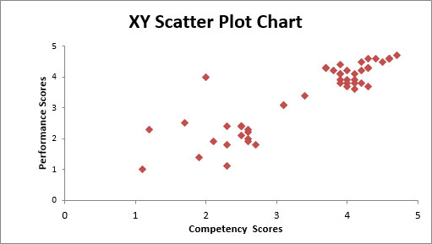
A scatter chart in Excel (also known as an XY scatter plot chart) is excellent for showing correlations between two sets of values. For example, an XY scatter plot can be used to illustrate the correlation between employee performance and competency, demonstrating that employee performance rises as competency improves. The x– and y-axes work together to represent data plots on the chart based on the intersection of x values and y values.

Components of dashboard
A dashboard's effectiveness depends on a few key components that make it useful and easy to understand. Here are the most important ones,
Intention
Layout
Charts
Kpi
Slicer
Navigation (for multi dashboard)
Heading
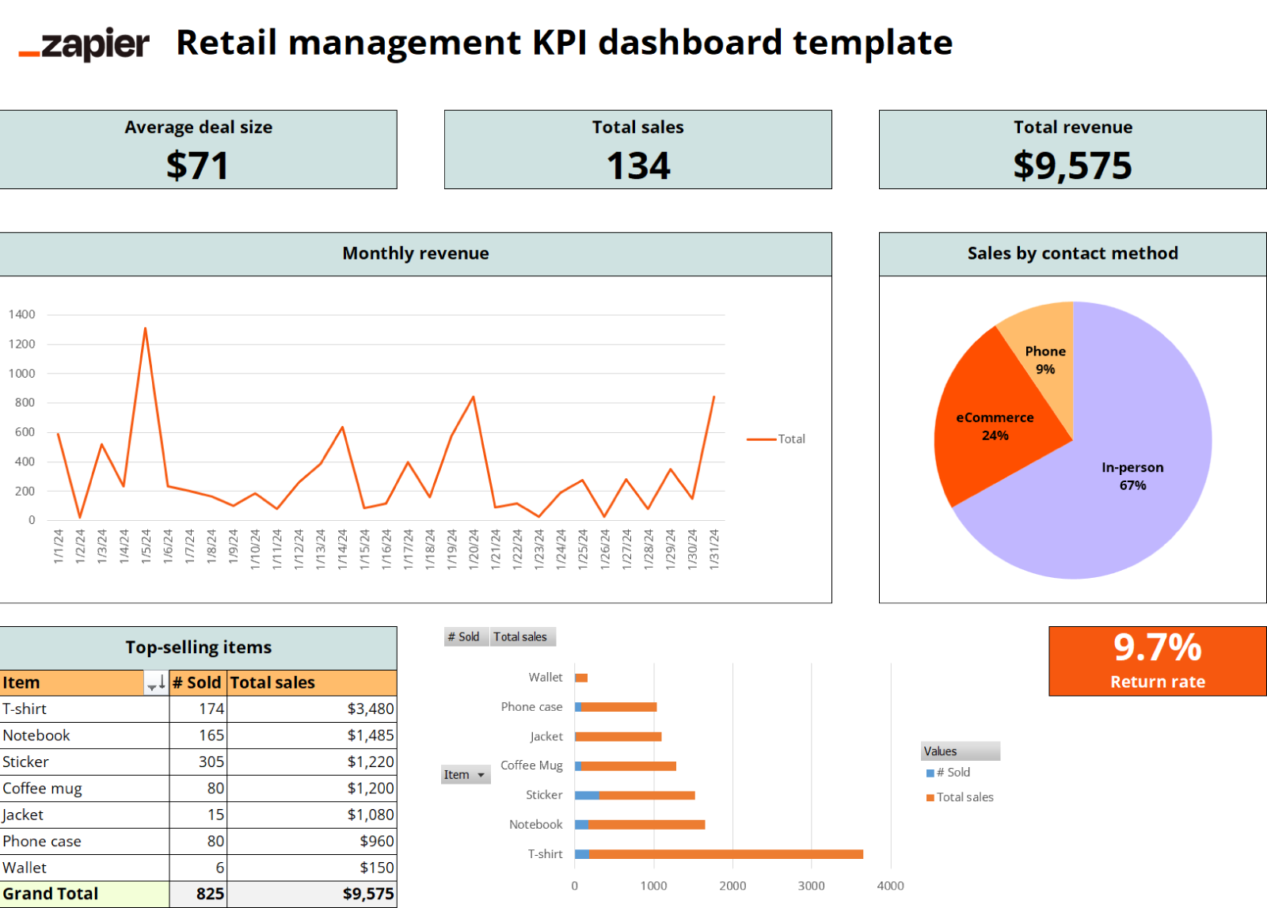

KPI
Key Performance Indicator
Think of it as a score that tracks progress on something specific you care about.
In a dashboard, KPIs are often shown as numbers to give a clear snapshot of performance.
Why are KPIs important?
- They focus on what matters most, like profit or customer satisfaction.
- They help you track progress over time (e.g., are sales improving?).
- They make it easier to spot problems

